Sample Social Media Content for Sharing News About NORD’s Drug Development Series
All creative assets can be found in “social creative assets” folder
Please be sure to tag NORD (Facebook, X, Instagram, LinkedIn), FDA (Facebook, X, Instagram, LinkedIn) and Critical Path (Facebook, X, LinkedIn)!
Post #1 – Facebook or LinkedIn | Hashtags | Creative #1
Less than 5% of #RareDiseases have an approved treatment - and you can help find a treatment for those that don’t.  In partnership with the [TAG] FDA and [TAG] Critical Path Institute, the National Organization for Rare Disorders (NORD) developed a free, online course designed to help you transform your personal experiences into meaningful contributions to #RareDisease treatment research. Learn how to navigate the regulatory landscape, collaborate with key players in drug development, access experimental treatments and more.  Whether you’re a patient, caregiver or advocate, this course will provide the tools you need to play YOUR role in developing treatments for your disease. Visit Rare Disease Drug Development Series - NORD® Learning (rarediseases.org) to watch Dr. Collins’s full interview and learn how you, too, can help bring new hope to the 95% of rare diseases with no therapy! | #RareDisease | 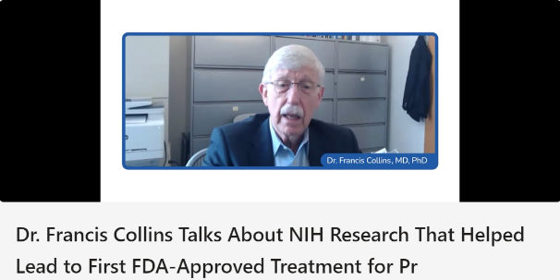  Quote  “FDA can be your partner in these situations. And they like that. They like to know what you’re doing. They like to have a chance well in advance of when you come to them with a formal proposal for a trial to be part of your deliberations. We learned that along the way.”

Post #2 - Instagram |  | Creative #2
When you or a loved one are diagnosed with a #RareDisease that has no known treatment, the news can be overwhelming.  The good news is, you can make a difference – and we’re here to show you how. Working with the [TAG] FDA and the [TAG] Critical Path Institute, the National Organization for Rare Disorders (NORD) created a course to help you effectively participate in the drug development process for your disease. This 3-part series gives you the tools you need to:  - Organize and rally your disease community to participate in drug development  - Transform personal experiences to help advance research  - Collaborate with FDA and pharmaceutical companies  By becoming drug development champions, you can help forge a new future for people with #RareDiseases – tap the link in our bio to learn how! | #RareDisease | 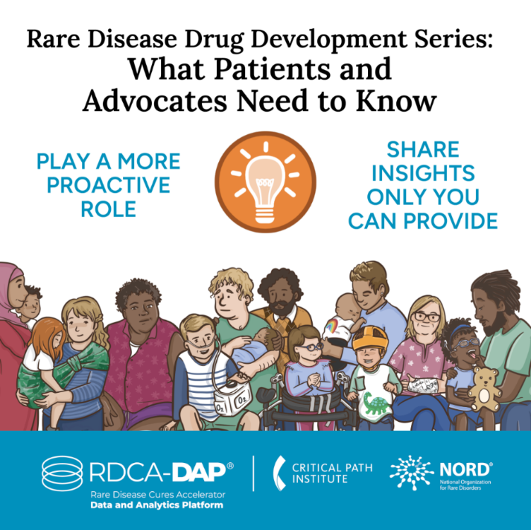

Post #3 – Facebook or LinkedIn |  | Creative #3
You have a powerful role to play in developing treatments for your disease. Get started by learning:  - What information you can share about your disorder that can influence researchers  - The steps for getting the green light to repurpose approved drugs for your condition  - The phases of the drug development process in which patient participation is most important  Together with the [TAG] FDA and [TAG] Critical Path Institute, the National Organization for Rare Disorders (NORD) created a FREE training course to help the #RareCommunity better understand rare disease drug development and share real stories from experts who have been in YOUR shoes!  You have the power to help improve the rare disease treatment landscape. Sign up now by visiting Rare Disease Drug Development Series - NORD® Learning (rarediseases.org) | #RareDisease  #RareCommunity | 